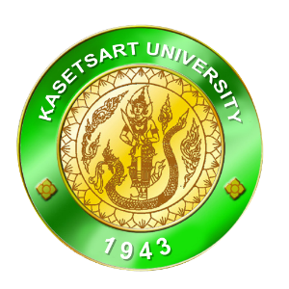

No. / 2005

TO WHOM IT MAY CONCERN

This is to certify that Miss Nuttaporn, with the student ID No.44203263, has completed a Bachelor Degree of Business Administration in International Business at the Faculty of Management Sciences, Kasetsart University, Siracha Campus.

The following comments indicate general performances:

 | Poor | Fair | Satisfactory | Good | Excellent
1.Education Attainment
2.Intellectual Ability
3.Leadership Potential
4.Personality/Ability to get along well with others
5.English Proficiency

ADDITIONAL COMMENTS:
…………………………………………………………………………………………………………………………………………………………………………………………………………………………………………………………………………………………………………………………………………………………………………………………………………………………………………………………………………

Given on March 2005

(Miss.Vorakamol Sarayangkul)
Lecturer

(NOT VALID WITHOUT KASETSART UNIVERSITY SEAL)

